

FinanceRite is registered with the Reserve Bank of Malawi under the Financial Services Act, 2010 and the Microfinance Act 2010 license No: MCA 017/18

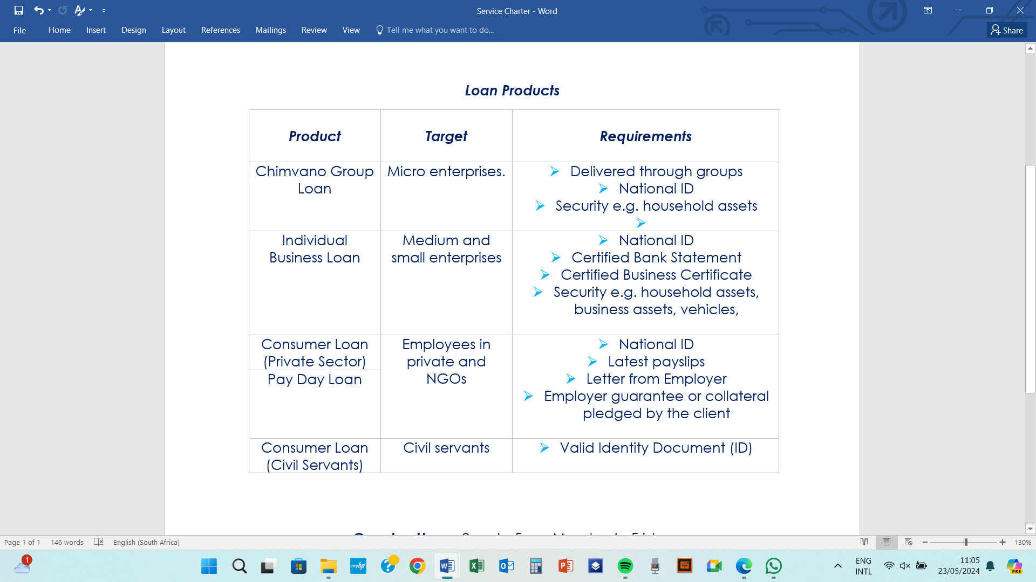

**Opening Hours:** 8am to 5pm, Monday to Friday

**Physical Address:** Unit No. FF38, Alliance Mall

**Postal Address:** P.O. Box 30044, Lilongwe, Malawi

For further information

Call: **0999 150 020 | 0881 625 829 | 0881 625 672**

Email:[**info@financerite.co.mw**](mailto:info@financerite.co.mw)

Visit:[**www.financerite.co.mw**](http://www.financerite.co.mw)